Unit 2 -8051 Assembly Language Programming and I/O
Port Programming
Q.1 With the help of ADD instruction explain:
a) Direct addressing mode
b) Indirect addressing mode
c) Register addressing mode
d) Immediate addressing mode.

1) Direct Addressing mode
ADD A,add
A ←A+(add)
ADD A,12H
The contents of memory location specified by 8 bit direct address will be logically ADDED bit by bit with the
contents of accumulator result is stored in accumulator.

2)Indirect addressing mode
ADD A,@Ri
A ←A+(Ri)
ADD A,@R0
The content of memory location whose address is specified by Ri(R0/R1) will be logically added bit by bit with
contents of accumulator. Result is stored in accumulator.
3) Register addressing mode
ADD A ,Rn
A ←A+Rn
ADD A,R2
The contents of specified register Rn (R0-R7) will be logically ADDED bit by bit with the contents of
accumulator result stored in Accumulator.
4) Immediate addressing mode
ADD A,#data
A ←A+#data
ADD A,#23H
Immediate data is logically ADDED bit by bit with contents of accumulator and result is stored in accumulator.

Q.2 Write an ALP for 8051 microcontroller to copy block of ten bytes of data from RAM location starting from 35H to RAM location starting at 60H.
Ans: (any relevant correct program with comments – 6 marks)
ORG 0000H ;Program from 0000H
MOV R3, #10 ;Initialize Byte counter
MOV R0, #35H ;Initialize memory pointer for source array
MOV R1, #60H ;Initialize memory pointer for destination array
; therefore R0 ---> Source pointer R1 ---> destination pointer
UP: MOV A, @R0 ; Read number from source array
MOV @R1, A ; Write number to destination array
INC R0 ;Increment source memory pointer by 1
INC R1 ; Increment destination memory pointer by 1
DJNZ R3, UP ; Decrement byte counter by 1 ; Is it zero? No, jump to UP
HERE: SJMP HERE
END ; Stop

Q.3State any four addressing modes of 8051 microcontroller and explain with one example each.
Ans: There are a number of addressing modes available to the 8051 instruction set, as follows:
1. Immediate Addressing mode
2. Register Addressing mode
3. Direct Addressing mode
4 Register Indirect addressing mode
5. Relative Addressing mode
6. Absolute addressing mode
7. Long Addressing mode
8. Indexed Addressing mode

1) Immediate Addressing mode:
Immediate addressing simply means that the operand (which immediately follows the Instruction op. code) is the data value to be used.
For example the instruction:
MOV A, #25H ; Load 25H into A

Moves the value 25H into the accumulator. The # symbol tells the assembler that the immediate addressing mode is to be used.
2 ) Register Addressing Mode:
One of the eight general-registers, R0 to R7, can be specified as the instruction Operand. The assembly language documentation refers to a register generically as Rn.
An example instruction using register addressing is :

ADD A, R5 ; Add the contents of register R5 to contents of A (accumulator)
Here the contents of R5 are added to the accumulator. One advantage of register addressing is that the instructions tend to be short, single byte instructions.
3) Direct Addressing Mode:
Direct addressing means that the data value is obtained directly from the memory location specified in the operand.
For example consider the instruction:
MOV R0, 40H; Save contents of RAM location 40H in R0.
The instruction reads the data from Internal RAM address 40H and stores this in the R0. Direct addressing can be used to access Internal RAM, including the SFR registers.
4) Register Indirect Addressing Mode:
Indirect addressing provides a powerful addressing capability, which needs to be appreciated.
An example instruction, which uses indirect addressing, is as follows:
MOV A, @R0; move contents of RAM location whose address is held by R0 into A
Note the @ symbol indicated that the indirect addressing mode is used. If the data is inside the CPU, only registers R0 & R1 are used for this purpose.
5) Relative Addressing Mode:
This is a special addressing mode used with certain jump instructions. The relative address, often referred to as an offset, is an 8-bit signed number, which is automatically added to the PC to make the address of the next instruction. The 8-bitsigned offset value gives an address range of + 127 to –128 locations.
Consider the following example:
SJMP LABEL_X
An advantage of relative addressing is that the program code is easy to relocate in memory in that the addressing is relative to the position in memory.
6) Absolute addressing Mode:
Absolute addressing within the 8051 is used only by the AJMP (Absolute Jump) and ACALL (Absolute Call) instructions.
7) Long Addressing Mode:
The long addressing mode within the 8051 is used with the instructions LJMP and LCALL. The address specifies a full 16 bit destination address so that a jump or a call can be made to a location within a 64KByte code memory space (216 = 64K).
An example instruction is:
LJMP 5000h; full 16 bit address is specified in operand

8) Indexed Addressing Mode:
With indexed addressing a separate register, either the program counter, PC, or the data pointer DTPR, is used as a base address and the accumulator is used as an offset address. The effective address is formed by adding the value from the base address to the value from the offset address.
Indexed addressing in the 8051 is used with the JMP or MOVC instructions. Look up tables are easy to implement with the help of index addressing.
Consider the example instruction:
MOVC A, @A+DPTR
MOVC is a move instruction, which moves data from the external code memory space. The address operand in this example is formed by adding the content of the DPTR register to the accumulator value. Here the DPTR value is referred to as the base address and the accumulator value us referred to as the index address.

Q.4 State necessity of Assembler directives. List any four assembler directives and describe with example.
(i) ORG (ii) DB (iii) EQU (iv) END
Ans: i) ORG:-ORG stands for Origin
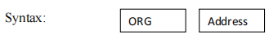
The ORG directive is used to indicate the beginning of the address. The number that
comes after ORG can be either in hex or in decimal. If the number is not followed by H, it is decimal and the assembler will convert it to hex. Some assemblers use ―.ORG‖ (notice the dot) instead of ―ORG‖ for the origin directive.
ii) DB:- (Data Byte)

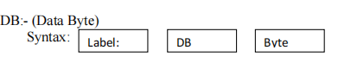
Where byte is an 8-bit number represented in either binary, Hex, decimal or ASCII form.
There should be at least one space between label & DB. The colon (:) must present after label. This directive can be used at the beginning of program. The label will be used in program instead of actual byte. There should be at least one space between DB & a byte.
Following are some DB examples:
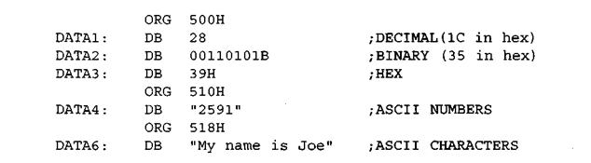
iii)EQU: Equate
It is used to define constant without occupying a memory location
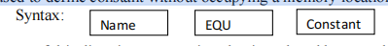
By means of this directive, a numeric value is replaced by a symbol.
For e.g. MAXIMUM EQU 99 After this directive every appearance of the label
―MAXIMUM‖ in the program, the assembler will interpret as number 99
(MAXIMUM=99).
iv) END:
This directive must be at the end of every program.meaning that in the source code
anything after the END directive is ignored by the assembler.
This indicates to the assembler the end of the source file(asm).
Once it encounters this directive, the assembler will stop interpreting program into
machine code.
e.g. END ; End of the program.

Q.5 Write a program to find the sum of data stored at five consecutive memory locations starting from 40H.Store lower byte in A and higher byte in R7.
Assume data 40H=7D 41H=EB 42H= C5 43H= 5B 44H= 32

CLR PSW.3 ; Select register Bank 0
CLR PSW.4;
MOV Ro, #05H ; Initialize byte counter
MOV R1, #40H ; Initialize memory pointer
MOV R7, #00H ; Initialize MSB COUNTER
MOV A, # 00H ; Clear Accumulator
UP: ADD A @R1; Add accumulator with number from array
INC R1 ; Increment memory pointer
DJNZ R0, UP ; Decrement byte counter, ; if byte counter ≠ 0 ; Then go to UP
JC Down ; If result greater than 8 bit then go to Down
Down: INC R7 ; higher byte in R7
MOV30H, A ; lower byte Is Available in A, or Store result in internal memory)
HERE: SJMP HERE
END ; Stop

Q6 Describe following microcontroller instructions
i)LJMP addr ii) SJMP addr iii) RL A iv) RR A

i) LJMP addr: Long Address
The program counter is loaded with the 16-bit long address given in 2 nd and 3rd
byte of the instruction. Jump can take place anywhere in the 64KB memory space.
PC addr
Example: LJMP 3245H
PC 3245
The next instruction executes from the memory location 3245H.
ii) SJMP addr: Short address
PCnew PCold +addr
The program control jumps max 128 bytes backwards or max 127 bytes forward
with respect to the current PC. Next instruction is executed from new PC.
iii) RL A: Rotate accumulator left.
It stands for rotate accumulator left. The contents of the Accumulator are rotated
left bit-wise.
Example:
Before execution

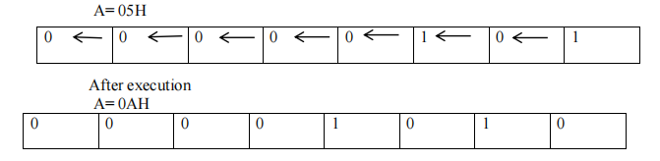

iv) RR A: Rotate accumulator right.
It stands for rotate accumulator right. The contents of the Accumulator are rotated
right bit-wise.
Example:
Before execution

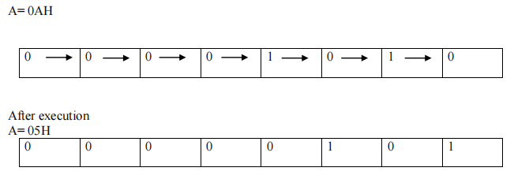

Q.7Explain the following 8051 microcontroller instructions:
(i) XCH A, @Ri
(ii) CJNE A, direct, rel
Ans:
(i) XCH A, @Ri
Exchange the contents of the accumulator with the contents of the memory location pointed by the 8 bit register in the instruction.
Example: XCH A, @R1
Exchange the contents of the accumulator with the contents of the memory location pointed by the R1 register.

(ii) CJNE A, direct, rel
Compare the contents of the accumulator with the 8 bit data directly mentioned in the instruction and if they are not equal then jump to the relative address mentioned in the instruction.
Example: CJNE A, 04H, UP
Compare the contents of the accumulator with the 04H mentioned in the instruction and if they are not equal then jump to the line of instruction where UP label is mentioned

Q.8 Describe the function of following instruction of 8051 microcontroller.
(i)MOV A,@Ri
(ii)MOVX A,@DPTR
(iii)SWAP A
(iv)INC@ Ri

(i)
MOVA, @R0
This instruction moves the contents of memory location pointed by R0 to the Accumulator
No of bytes : 1
Addressing mode: register indirect No flags affected
Example: MOV R0, #40H ; R0=40H(internal RAM address)
MOV A,@R0 ; 40H= 25H(Value present in internal memory pointed by R0)
; A = 25H
(ii) MOVX A,@DPTR
This instruction moves the contents of the external RAM memory pointed by (or stored in) DPTR to accumulator.
Example: MOV DPTR, # 2000H ; DPTR = 2000H(external RAM address)
MOV A, @DPTR ; 2000H = 0BH
;A = 0BH

(iii) SWAP A
This instruction interchanges bits 0-3 i.e. lower nibble (D0-D3) of the Accumulator with bits 4-7 i.e. upper nibble (D4-D7) of the Accumulator. This instruction is identical to executing "RR A" or "RL A" four times.
No of bytes: 1 byte
Addressing mode: register specific
Example: MOV A, #59H ;A= 59H ( 0101 1001 in binary)
SWAP A ; A= 95H (1001 0101 in binary)
(iv) INC @Ri
These instruction increments indirect RAM by 1. It increments the contents of memory location pointed by Ri by 1.
Example: MOV R0, # 40H ; R0 =40H( Sets the memory pointer)
;40H = 05H;
INC @R0 ; Increments contents pointed by R0 by 1
;40H =06H (After execution)

Q.9 Write an ALP to find smallest number from given array of 10 bytes in internal RAM 40h onwards.
MOV R1, #0AH; Initialize Byte Counter
MOV R0, #40H; Initialize source pointer R0 to 40H
DEC R1; decrement counter by one
MOV 60H, @R0 Read First Byte
UP: INC R0; Increment the contents of R0
MOV A, @R0; Read second number
CJNE A, 60H, DN compare the first two numbers, if not equal go to DOWN
AJMP SMALL else go to small
DN: JNC SMALL check carry
MOV 60H, A Store smallest number to 60H
SMALL: DJNZ R1, UP decrement the counter by one, if count ≠ 0, then go to UP
END
Smallest No. is saved in memory 60H

Q.10 Write an assembly language program to find largest number from the array of five numbers stored in internal RAM memory.
MOV R1, #05H ; initialize the counter
MOV R0, #40H ; initialize the memory pointer
DEC R1 ; decrement counter by one
MOV A,@R0 ; load number in accumulator
MOV B, A; move that number to register B
UP: INC R0; increment the memory pointer
MOV A,@R0 ; read the next number in A
CJNE A, B, DOWN ; compare the first two numbers, if not equal go to DOWN
AJMP NEXT; else go to NEXT
DOWN: JC NEXT; if number in A is greater then go to NEXT
MOV B, A ; else move the number in register B
NEXT: DJNZ R1, UP ; decrement the counter by one, if count ≠ 0, then go to UP INC R0 ; increment the memory pointer
MOV A,B
MOV 50H, A ; store result at memory location 50H
HERE: SJMP HERE

Q11.Explain the function of following instructions
i. DAA
ii. ANL
iii. RET
iv. SWAP A

i)DAA
Description: DA adjusts the contents of the Accumulator to correspond to a BCD
(Binary Coded Decimal) number after two BCD numbers have been added by the ADD or
ADD C instruction. If the carry bit is set or if the value of bits 0-3 exceed 9, 0x06 is added to the accumulator. If the carry bit was set when the instruction began, or if 0x06 was added to the accumulator in the first step, 0x60 is added to the accumulator
The Carry bit (C) is set if the resulting value is greater than 0x99, otherwise it is
cleared.
Example: MOV A, # 47H ; A= 0100 0111
ADD A, # 38 H ; A= 47 H + 38H = 7FH, invalid BCD DA A
; A= 1000 0101 =85 H, valid BCD
ii) ANL
Description: This instruction performs bitwise logical AND operation between the
variables indicated and stores the result in the destination variable.
No flags are affected.
Example :ANL A,Rn
iii) RET
Description: RET pops the high and low order bytes of the PC successively from the stack, decrementing the stack pointer by two program execution at the resulting address.
No flags are affected
Example: the stack pointer originally contains the value 0BH, internal RAM location
contain the values 23H and 01H,respectively .
RET will leave the stack pointer equal to value 09h.Program execution will continue at location 0123H.
iv) SWAP A
Description: This instruction exchanges bits 0-3 of the Accumulator with bits 4-7 of the Accumulator. This instruction is identical to executing "RR A" or "RL A" four times.
No of bytes: 1 byte
Addressing mode: register specific
Example: MOV A, #59H ; A= 59H
SWAP A ; A= 95H

Q Write assembly language program to multiply two 8 bit numbers store result at 55 H.
MOV 10H, # 23H ; store first 8-bit no. in 10H
MOV 11H, #15H ; store second 8-bit no. in 11H
MOV A, 10H ; move first number to A
MOV B, 11H ; move second number to B
MUL AB ; multiply the numbers
MOV 55H, A ; move result to 55H
HERE: SJMP HERE

- Write a program to arrange 8 numbers in array stores in internal RAM in ascending order
MOV R3, #08H; Initialize the pass counter
UP1: MOV R0, #40H ; Initialize the memory pointer
MOV R7, #05H ; Initialize the byte counter
UP: MOV A, @R0; Read number from array
MOV 0F0H, A ; Copy number to B register
INC R0; Increment memory pointer
MOVA,@R0; Read next number from array
CJNE A, 0F0, DWN ; Compare number with next number
AJMP SKIP
DWN: JNC SKIP ; If number> next number then go to SKIP
MOV R0, R3; Else exchange the number with next number
MOV @R0, A
INC R0
MOV A, 0F0H
MOV@R0, A
SKIP: DJNZ R3, UP ; Decrement byte counter if not zero, go to UP
DJNZ R7 UP1 ; Decrement pass counter if not zero, go to UP1
LOOP: AJMP LOOP
; Stop

Q.12 Write addressing modes for following instructions:
(i) ADD A, R0
(ii) ADD A, #20h
(iii) ADD A, 50h
(iv) ADD A, @R0

i) ADD A,R0 Register addressing mode
ii) ADD A,#20h Immediate addressing mode
iii)ADD A,50h Direct addressing mode
iv)ADD A,@R0 Indirect addressing mode

Q.11 Write an ALP to arrange 10 bytes starting from 50h onwards, in descending order.
ORG 0000h
MOV R0,#50H ; Initialize memory pointer
MOV R2, #0AH ; initialize counter 1
UP2: MOV R1, #50H ; Initialize the memory pointer
MOV R3,#0AH ; initialize counter 2
UP1: MOV A, @R0 ; get the first byte from memory pointer R0
MOV 0F0H, @ R1 ; get the first byte from memory pointer R1
CJNE A,0F0H,DOWN ; compare the two bytes
DOWN:JC A_SMALL ; if carry is 1, ie R0 data is smaller go to A_SMALL
MOV @R0,0F0H ; if Carry =0, get smaller data to R0 from R1
MOV @R1,A
A_SMALL: INC R1 ; increment R1
DJNZ R3,UP1 ; decrement R3 and repeat till it is 0
INC R0 ; increment R0
DJNZ R2,UP2 ; decrement R2 and repeat till it is 0
SJMP $

Introduction to 8051 Programming in Assembly Language
The assembly language is a low-level programming language used to write program code in terms of mnemonics. Even though there are many high-level languages that are currently in demand, assembly programming language is popularly used in many applications.It can be used for direct hardware manipulations. It is also used to write the 8051 programming code efficiently with less number of clock cycles by consuming less memory compared to the other high-level languages.
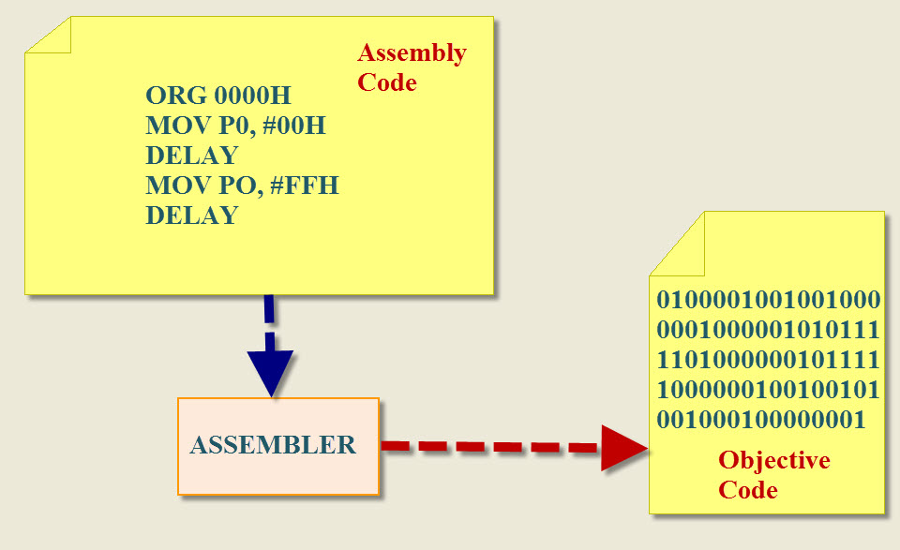8051 Programming

8051 Programming in Assembly Language
The assembly language is a fully hardware related programming language. The embedded designers must have sufficient knowledge on hardware of particular processor or controllers before writing the program. The assembly language is developed by mnemonics; therefore, users cannot understand it easily to modify the program.
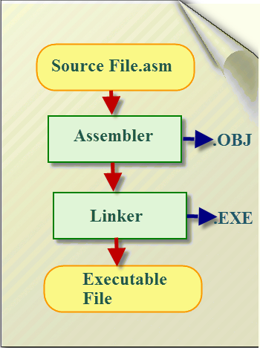8051 Programming in Assembly Language
Assembly programming language is developed by various compilers and the “keiluvison” is best suitable for microcontroller programming development. Microcontrollers or processors can understand only binary language in the form of ‘0s or 1s’; An assembler converts the assembly language to binary language, and then stores it in the microcontroller memory to perform the specific task.

8051 Microcontroller Architecuture
The 8051 microcontroller is the CISC based Harvard architecture, and it has peripherals like 32 I/O, timers/counters, serial communication and memories. The microcontroller requires a program to perform the operations that require a memory for saving and to read the functions. The 8051 microcontroller consists of RAM and ROM memories to store instructions.
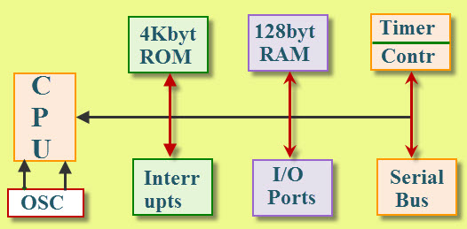8051 Microcontroller Architecuture
A Register is the main part in the processors and microcontrollers which is contained in the memory that provides a faster way of collecting and storing the data. The 8051 assembly language programming is based on the memory registers. If we want to manipulate data to a processor or controller by performing subtraction, addition, etc., we cannot do that directly in the memory, but it needs registers to process and to store the data. Microcontrollers contain several types of registers that can be classified according to their instructions or content that operate in them.

8051 Microcontroller Programs in Assembly Language
The assembly language is made up of elements which all are used to write the program in sequential manner. Follow the given rules to write programming in assembly language.

Rules of Assembly Language
- The assembly code must be written in upper case letters
- The labels must be followed by a colon (label:)
- All symbols and labels must begin with a letter
- All comments are typed in lower case
- The last line of the program must be the END directive
The assembly language mnemonics are in the form of op-code, such as MOV, ADD, JMP, and so on, which are used to perform the operations.
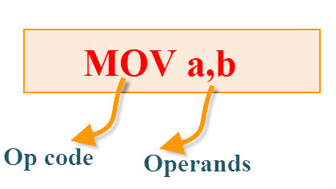
Op-code: The op-code is a single instruction that can be executed by the CPU. Here the op-code is a MOV instruction.
Operands: The operands are a single piece of data that can be operated by the op-code. Example, multiplication operation is performed by the operands that are multiplied by the operand.
Syntax: MUL a,b;

The Elements of an Assembly Language Programming:
- Assembler Directives
- Instruction Set
- Addressing Modes
Assembler Directives:
The assembling directives give the directions to the CPU. The 8051 microcontroller consists of various kinds of assembly directives to give the direction to the control unit. The most useful directives are 8051 programming, such as:
- ORG
- DB
- EQU
- END
ORG(origin): This directive indicates the start of the program. This is used to set the register address during assembly. For example; ORG 0000h tells the compiler all subsequent code starting at address 0000h.
Syntax: ORG 0000h
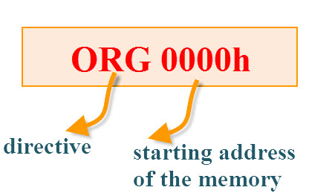
DB(define byte): The define byte is used to allow a string of bytes. For example, print the “EDGEFX” wherein each character is taken by the address and finally prints the “string” by the DB directly with double quotes.
Syntax:
ORG 0000h
MOV a, #00h
————-
————-
DB”EDGEFX”
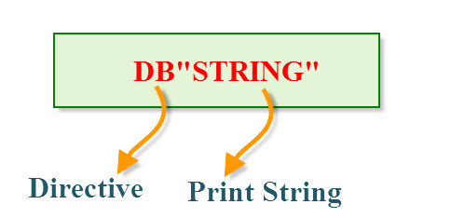
EQU (equivalent): The equivalent directive is used to equate address of the variable.
Syntax:
reg equ,09h
—————–
—————–
MOV reg,#2h
END:The END directive is used to indicate the end of the program.
Syntax:
reg equ,09h
—————–
—————–
MOV reg,#2h
END

Addressing Modes:
The way of accessing data is called addressing mode. The CPU can access the data in different ways by using addressing modes. The 8051 microcontroller consists of five addressing modes such as:
- Immediate Addressing Mode
- Register Addressing Mode
- Direct Addressing Mode
- Indirect Addressing Mode
- Base Index Addressing Mode
Immediate Addressing Mode:
In this addressing mode, the source must be a value that can be followed by the ‘#’ and destination must be SFR registers, general purpose registers and address. It is used for immediately storing the value in the memory registers.
Syntax:
MOV A, #20h //A is an accumulator register, 20 is stored in the A//
MOV R0,#15 // R0 is a general purpose register; 15 is stored in the R0 register//
MOV P0, #07h //P0 is a SFR register;07 is stored in the P0//
MOV 20h,#05h //20h is the address of the register; 05 stored in the 20h//
Ex:
MOV R0, #1
MOV R0, #20 //R0 <—R0[15]+20, the final value is stored in R0//

Register Addressing Mode:
In this addressing mode, the source and destination must be a register, but not general purpose registers. So the data is not moved within the general purpose bank registers.
Syntax:
MOV A, B; // A is a SFR register, B is a general purpose register//
MOV R0, R1 //Invalid instruction, GPR to GPR not possible//
EX:
MOV R0, #02h
MOV A, #30h
ADD R0, A //R0<—R0+A, the final value is stored in the R0 register//
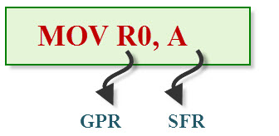
Direct Addressing Mode
In this addressing mode, the source or destination (or both source and destination) must be an address, but not value.
Syntax:
MOV A,20h // 20h is an address; A is a register//
MOV 00h, 07h // both are addressed of the GPS registers//
Ex:
MOV 07h,#01h
MOV A, #08h
ADD A,07h //A<—A+07h the final value is stored in A//
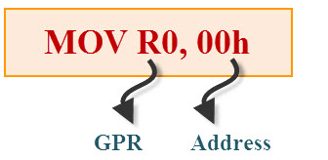
Indirect Addressing Mode:
In this addressing mode, the source or destination (or destination or source) must be a indirect address, but not a value. This addressing mode supports the pointer concept. The pointer is a variable that is used to store the address of the other variable. This pointer concept is only used for R0 and R1 registers.
Syntax:
MOVR0, #01h //01 value is stored in the R0 register, R0 address is 08h//
MOV R1, #08h//R1 is the pointer variable that stores address (08h) of R0 //
MOV 20h,@R1 //01 value is stored in the 20h address of the GP register//
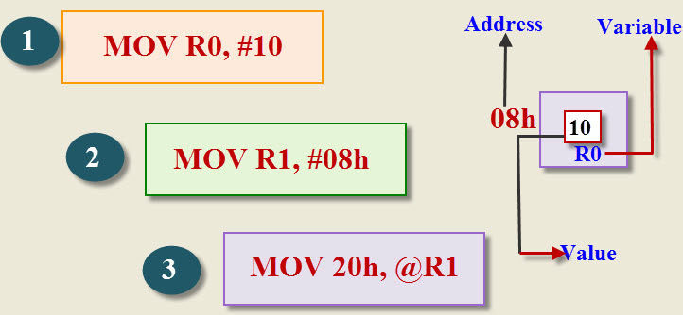Indirect Addressing Mode
Base Index Addressing Mode:
This addressing mode is used to read the data from the external memory or ROM memory. All addressing modes cannot read the data from the code memory. The code must read through the DPTR register. The DPTR is used to point the data in the code or external memory.
Syntax:
MOVC A, @A+DPTR //C indicates code memory//
MOCX A, @A+DPTR // X indicate external memory//
EX: MOV A, #00H //00H is stored in the A register//
MOV DPTR, #0500H //DPTR points 0500h address in the memory//
MOVC A, @A+DPTR //send the value to the A register//
MOV P0, A //date of A send to the PO registrar//

Instruction Set:
The instruction set is the structure of the controller or processor that provides commands to the controller to guide the controller for processing data. The instruction set consists of instructions, native data types, addressing modes, interrupt registers, exceptional handling and memory architecture. The 8051 microcontroller can follow CISC instructions with Harvard architecture. In case of the 8051 programming different types of CISC instructions include:
- Data Transfer Instruction set
- Sequential Instruction Set
- Arithmetic Instruction set
- Branching Instruction set
- Loop Instrcution Set
- Conditional Instruction set
- Unconditional Instruction set
- Logical Instruction set
- Boolean Instruction set

Arithmetic Instruction Set:
The arithmetic instructions perform the basic operations such as:
- Addition
- Multiplication
- Subtraction
- Division
Addition:
ORG 0000h
MOV R0, #03H // move the value 3 to the register R0//
MOV A, #05H // move the value 5 to accumulator A//
Add A, 00H // addA value with R0 value and stores the result inA//
END
Multiplication:
ORG 0000h
MOV R0, #03H // move the value 3 to the register R0//
MOV A, #05H // move the value 5 to accumulator A//
MUL A, 03H // Multiplied result is stored in the Accumulator A //
END
Subtraction:
ORG 0000h
MOV R0, #03H // move the value 3 to register R0//
MOV A, #05H // move the value 5 to accumulator A//
SUBB A, 03H // Result value is stored in the Accumulator A //
END
Division:
ORG 0000h
MOV R0, #03H // move the value 3 to register R0//
MOV A, #15H // move the value 5 to accumulator A//
DIV A, 03H // final value is stored in the Accumulator A //
END
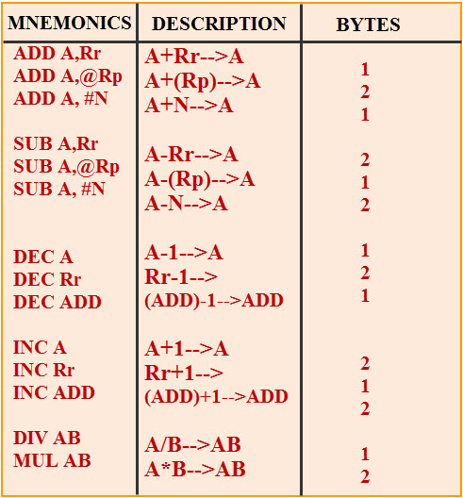

Conditional Instructions
The CPU executes the instructions based on the condition by checking the single bit status or byte status. The 8051 microcontroller consists of various conditional instructions such as:
- JB —>Jump below
- JNB —> Jump if not below
- JC —> Jump if Carry
- JNC —>Jump if not Carry
- JZ —>Jump if Zero
- JNZ —> Jump if not Zero
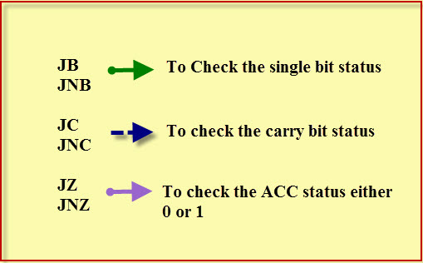Conditional Instructions
1. Syntax:
JB P1.0, label
– – – – – – – –
– – – – – – – –
Label: – – – – – – – –
– – – – – – – –
END
2. Syntax:
JNB P1.0, label
– – – – – – – –
– – – – – – – –
Label: – – – – – – – –
– – – – – – – –
END

3. Syntax:
JC, label
– – – – – – – –
– – – – – – – –
Label: – – – – – – – –
– – – – – – – –
END
4. Syntax:
JNC, label
– – – – – – – –
– – – – – – – –
Label: – – – – – – – –
– – – – – – – –
END
5. Syntax:
JZ, label
– – – – – – – –
– – – – – – – –
Label: – – – – – – – –
– – – – – – – –
END
6. Syntax:
JNZ, label
– – – – – – – –
– – – – – – – –
Label: – – – – – – – –
– – – – – – – –
END

Call and Jump Instructions:
The call and jump instructions are used to avoid the code replication of the program. When some specific code used more than once in different places in the program, if we mention specific name to code then we could use that name anywhere in the program without entering a code for every time. This reduces the complexity of the program. The 8051 programming consists of call and jump instructions such as LCALL, SJMP.
- LCALL
- ACALL
- SJMP
- LJMP
1. Syntax:
ORG 0000h
– – – – – – – –
– – – – – – – –
ACALL, label
– – – – – – – –
– – – – – – – –
SJMP STOP
Label: – – – – – – – –
– – – – – – – –
– – – – – – – –
ret
STOP:NOP
2. Syntax:
ORG 0000h
– – – – – – – –
– – – – – – – –
LCALL, label
– – – – – – – –
– – – – – – – –
SJMP STOP
Label: – – – – – – – –
– – – – – – – –
– – – – – – – –
ret
STOP:NOP
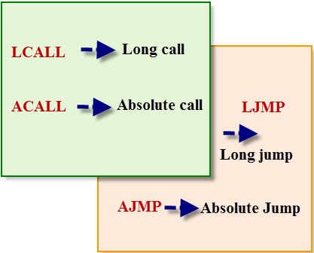Call and Jump Instructions

Loop Instructions:
The loop instructions are used to repeat the block each time while performing the increment and decrement operations. The 8051 microcontroller consist two types of loop instructions:
- CJNE —> compare and jump if not equal
- DJNZ —> decrement and jump if not zero
1. Syntax:
of CJNE
MOV A, #00H
MOV B, #10H
Label:INC A
– – – – – –
– – – – – –
CJNE A, label
2. Syntax:
of DJNE
MOV R0, #10H
Label:– – – – – –
– – – – – –
DJNE R0, label
– – – – – –
– – – – – –
END

Logical Instruction Set:
The 8051 microcontroller instruction set provides the AND, OR, XOR, TEST, NOT and Boolean logic instructions for set and clears the bits based on the need in the program.
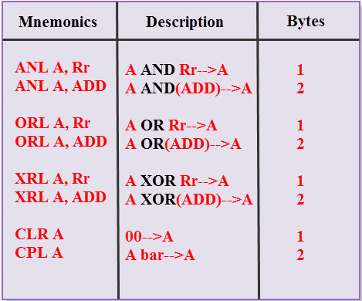Logical Instruction Set
1. Syntax:
MOV A, #20H /00100000/
MOV R0, #03H /00000101/
ORL A, R0 //00100000/00000101=00000000//
2. Syntax:
MOV A, #20H /00100000/
MOV R0, #03H /00000101/
ANL A, R0
3. Syntax:
MOV A, #20H /00100000/
MOV R0, #03H /00000101/
XRL A, R0

Shifting Operators
The shift operators are used for sending and receiving the data efficiently. The 8051 microcontroller consist four shift operators:
- RR —> Rotate Right
- RRC —>Rotate Right through carry
- RL —> Rotate Left
- RLC —>Rotate Left through carry
Rotate Right (RR):
In this shifting operation, the MSB becomes LSB and all bits shift towards right side bit-by-bit, serially.
Syntax:
MOV A, #25h
RR A
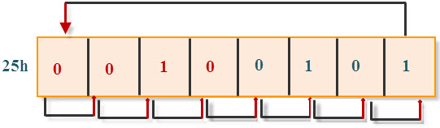
Rotate Left (RL):
In this shifting operation, the MSB becomes LSB and all bits shift towards Left side bit-by-bit, serially.
Syntax:
MOV A, #25h
RL A
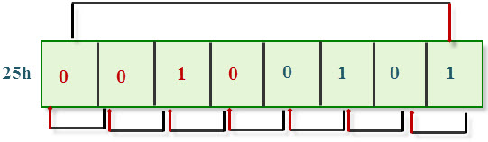
RRC Rotate Right through Carry:
In this shifting operation, the LSB moves to carry and the carry becomes MSB, and all the bits are shift towards right side bit by bit position.
Syntax:
MOV A, #27h
RRC A
RLC Rotate Left through Carry:
In this shifting operation, the MSB moves to carry and the carry becomes LSB and all the bits shift towards left side in a bit-by-bit position.
Syntax:
MOV A, #27h
RLC A

Basic Embedded C Programs:
The microcontroller programming differs for each type of operating system. There are many operating systems such as Linux, Windows, RTOS and so on. However, RTOS has several advantages for embedded system development. Some of the Assembly level programming examples are given below.

LED blinking using with 8051 microcontroller:
- Number Displaying on 7-segment display using 8051 microcontroller
- Timer/Counter calculations and program using 8051 microcontroller
- Serial Communication calculations and program using 8051 microcontroller

LED programs with 8051 Microcontrller
1. WAP to toggle the PORT1 LEDs
ORG 0000H
TOGLE: MOV P1, #01 //move 00000001 to the p1 register//
CALL DELAY //execute the delay//
MOV A, P1 //move p1 value to the accumulator//
CPL A //complement A value //
MOV P1, A //move 11111110 to the port1 register//
CALL DELAY //execute the delay//
SJMP TOGLE
DELAY: MOV R5, #10H //load register R5 with 10//
TWO: MOV R6, #200 //load register R6 with 200//
ONE: MOV R7, #200 //load register R7 with 200//
DJNZ R7, $ //decrement R7 till it is zero//
DJNZ R6, ONE //decrement R7 till it is zero//
DJNZ R5, TWO //decrement R7 till it is zero//
RET //go back to the main program //
END

Timer/Counter Calculations and Program using 8051 Microcontroller:
The delay is the one of the important factors in the application software development. The timers and counters are hardware components of the microcontroller, that are used in many applications to provide the accurate time delay with count pulses. Both the tasks are implemented by the software technique.
1. WAP to calculate the 500us time delay.
MOV TMOD, #10H //select the timer mode by the registers//
MOV TH1, #0FEH // store the delay time in higher bit//
MOV TL1, #32H // store the delay time in low bit//
JNB TF1, $ //decrement the value of the timer till it is zero//
CLR TF1 //clear the timer flag bit//
CLR TR1 //OFF the timer//
2. WAP to toggle the LEDs withthe 5 sec time delay
ORG 0000H
RETURN: MOV PO, #00H
ACALL DELAY
MOV P0, #0FFH
ACALL DELAY
SJUMP RETURN
DELAY: MOV R5, #50H //load register R5 with 50//
DELAY1: MOV R6, #200 //load register R6 with 200//
DELAY2: MOV R7, #229 //load register R7 with 200//
DJNZ R7, $ //decrement R7 till it is zero//
DJNZ R6, DELAY2//decrement R6 till it is zero//
DJNZ R5, DELAY1//decrement R5 till it is zero//
RET //go back to the main program //
END
3. WAP to count the 250 pulses using mode0 count0
Syntax:
ORG 0000H
MOV TMOD, #50H //select the counter//
MOV TH0, #15 //move the counting pulses higher bit//
MOV TH1, #9FH //move the counting pulses, lower bit//
SET TR0 //ON the timer//
JNB $ //decrement the count value till zero//
CLR TF0 //clear the counter, flag bit//
CLR TR0 //stop the timer//
END

Serial Communication Programming Using 8051 Microcontroller:
Serial communication is commonly used for transmitting and receiving the data. The 8051 microcontroller consist of UART/USART serial communication and the signals are transmitted and received by Tx and Rx pins. The UART communication transfers the data bit-by-bit serially. The UART is a half-duplex protocol that transfers and receives the data, but not at the same time.
1. WAP to transmit the characters to the Hyper Terminal
MOV SCON, #50H //set the serial communication//
MOV TMOD, #20H //select the timer mode//
MOV TH1, #-3 //set the baud rate//
SET TR1 //ON the timer//
MOV SBUF, #’S’ //transmit S to the serial window //
JNB TI, $ //decrement value of the timer till it is zero//
CLR RI // clear receive interrupt //
CLR TR1 //clear timer//
2. WAP to transmit the Receive the character by the Hyper Terminal
MOV SCON, #50H //set the serial communication//
MOV TMOD, #20H //select the timer mode//
MOV TH1, #-6 //set the baud rate//
SET TR1 //on the timer//
MOV SBUF, #’S’ //transmit S to the serial window //
JNB RI, $ //decrement value of timer till it is zero//
CLR RI // clear receive interrupt //
MOV P0, SBUF //send the SBUF register value to the port0//
CLR TR1 //clear timer//
This is all about the 8051 Programming in Assembly language in brief with example-based programs. We hope this adequate information on assembly language will be certainly helpful for the readers and we look forward for their valuable comments in the comment section below.

SHARE THIS POST:

Facebook

Twitter

Google+

LinkedIn

Pinterest

Post navigation
‹ PREVIOUSMicrocontroller based Electrical Projects
NEXT ›Understanding about Different Types of Automation Systems
RELATED CONTENT

Design of Android Controlled Automobiles Using 8051 Microcontroller
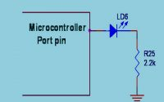
How to Interface an LED With 8051 Microcontroller
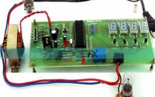
Digital Temperature Controller Circuit
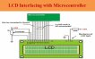
LCD Interfacing with 8051 Microcontroller
Comments are closed.
窗体顶端

窗体底端

RECENT POSTS
- Kogge Stone Adder : Circuit, Working, Advantages, Disadvantages & Its Applications
- Loop Antenna : Design, Working, Types, Radiation Pattern & Its Applications
- Brent Kung Adder : Circuit, Working, Advantages, Disadvantages & Its Applications
- Inverting Summing Amplifier : Circuit, Working, Derivation, Transfer Function & Its Applications
- Active Band Pass Filter : Circuit, Types, Frequency Response, Q Factor, Advantages & Its Applications
- Magnetic Starter : Circuit, Working, Wiring, Vs Contactor, Advantages & Its Applications
- Bode Plot : Table, Differences,Stability, Advantages, Disadvantages & Its Applications

PROJECTS
- 555 Timer Circuits (6)
- 8051 Projects (60+)
- Arduino Projects (40+)
- ARM Projects (100+)
- Communication Projects (140+)
- DTMF Projects (25+)
- ECE Projects (400+)
- EEE Projects (240+)
- EIE Projects (100+)
- Electrical Mini Projects (120+)
- Electrical Project Ideas (300+)
- Electronics Projects (160+)
- Embedded Projects (200+)
- GSM Projects (100+)
- Home Automation Projects (100+)
- IOT Projects (30)
- LabView Projects (100+)
- Matlab Projects (190+)
- Microcontroller Mini Projects (80+)
- Mini Project Circuits (20+)
- Mini Project Ideas (45+)
- PIC Projects (30+)
- Power Electronics Projects (45+)
- Raspberry Pi Projects (9)
- RFID Projects (70+)
- Robotics Projects (100+)
- Sensor Projects (40+)
- Solar Projects (150+)
- VLSI Projects (180+)
- Wireless Projects (100+)
- Zigbee Projects (120+)

CATEGORIES
- Communication
- Electrical
- Electronics
- Project Ideas
- Robotics
- Technology

RECENT COMMENTS
- K BALAJI on Simple Electronic Circuits for Beginners
- Anny Arbert on Gyroscope Sensor Working and Its Applications
- Abhuday dangi on What is a UJT Relaxation Oscillator – Circuit Diagram and Applications
- Satyadeo Vyas on Construction and Working of a 4 Point Starter

FOLLOW ON FACEBOOK
<="" img="" style="box-sizing: border-box; border: 0px; vertical-align: middle;">
- Advertise With Us
- Disclaimer
- Report Violation
- Image Usage Policy
- Privacy Policy
- Contact Us
Copyright 2013 - 2025 © Elprocus

